|  |
| --- |
| **Implementation of Video Feedback (FVB) Technology in Supporting Futsal Playing Skills** |
|  |
| |  | | --- | | Oman Hadiana1*, Ribut Wahidi2, Asep Mahpudin3, Muhammad Rama Sanjaya4 Ramanda Aditya Maulandani5,Deliya Anitiara Rufikah6 | | 1-6 Universitas Muhammadiyah Kuningan, Kuningan Indonesia | | * [hadianaoman@upmk.ac.id](mailto:hadianaoman@upmk.ac.id) | |
| **ABSTRACT** |
| *Futsal is a sport that has been growing rapidly in various countries, including Indonesia. However, despite the dynamic development of futsal, the achievements of futsal clubs under the Kuningan Regency Futsal Association (AFKab Kuningan) have not yet been able to compete at the regional level. Observations during training sessions and matches reveal that the futsal playing skills of AFKab Kuningan member players still require improvement. This community service activity aims to implement Video Feedback (VFB) in the futsal training process to enhance players' playing skills. The program comprises five stages: socialization, training, technology application, mentoring and evaluation, and program sustainability. The results of the community service activities demonstrate an improvement in the playing skills of futsal club players in AFKab Kuningan. The application of Video Feedback (VFB) technology has proven to be effective in enabling players and coaches to conduct direct evaluations of the game, leading to improvements in technique, tactics, and overall team coordination. Through VFB, coaches can deliver more specific feedback, while players gain a better understanding of their weaknesses and potential.*  ***Keywords:*** *Futsal Playing Skills, Video Feedback, Video Techlonogy* |
|
|

# **Introduction**

Futsal is a sport that is growing rapidly in various foreign countries, including in Indonesia, with various massive competitions and tournaments at various levels. However, despite the rapid development of futsal, in reality the achievements of futsal clubs that are members of the Kuningan Regency Futsal Association (AFKab Kuningan) have not been able to compete at the regional level (West Java Province), let alone at the national level. If we look at the aspect of the high enthusiasm of the people of Kuningan Regency, it can be seen from the various levels of education holding futsal tournaments in their respective schools. In addition, there are several organizing committees outside the school institution, such as the futsal tournament managed by Viking Kuningan every six months starting from Elementary School students to between Colleges, futsal games are competed.

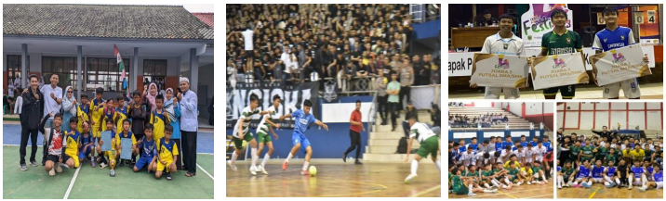

Figure 1. Gallery of the Inter-Elementary/Middle/High School Futsal Championship in Kuningan Regency

Since the establishment of the Kuningan Regency Futsal Association (AFKab Kuningan) on February 28, 2020, until now the futsal clubs under the auspices of AFKab have not been able to achieve success at the local or national level. It can be seen that every time a championship is held, especially in the West Java Province archipelago league, the best Kuningan futsal club representatives still have difficulty competing in the preliminary round. As a result, the Kuningan representative futsal club could not proceed to the next round. This problem is certainly a material for evaluation by the association and club, so that in the following year they can improve both in terms of competition quality, player selection, coaching, and the touch of science and technology that can improve the management and achievements of athletes and clubs. In 2023, AFKab Kuningan representatives Toko Kecil as Champion and Rahayu as Runner Up have not been organized by the province.

AFKab Kuningan has 13 official voter clubs as participants in the Kuningan Futsal League (KFL). The futsal competition held by the federation uses a half-competition system. The match equipment such as the referees assigned are professionals who have obtained legality in the form of a license. The coaches from each club in the KFL are coaches who have obtained a minimum national level license certificate. The KFL competition is an annual agenda of the federation as one of the work programs that must be held. The purpose of the federation from the KFL is to enliven the atmosphere of regional competition in order to be able to produce quality players and professional clubs so that they can continue to compete at the West Java regional level and at the National level.

The target of KFL is to channel the champion and runner-up clubs representing the Kuningan Regency Futsal Association to compete in the West Java Nusantara League (provincial level). If the club can compete and become a champion in the West Java Nusantara League, it will continue to participate as a participant in the National Nusantara League. Furthermore, the club and players' achievements in the National Nusantara League will be promoted to the National Futsal League. However, the results of the identification of several partner problems that we found include the futsal playing skills of AFKab Kuningan members still need to be improved, this is the result of observations during training and during matches. Players are not right in making decisions, for example the ball that is being controlled by a player that should be passed because the situation at that time the teammate is free without guard and the position is strategic, but the ball is still carried until it can be taken by the opposing player. The basic technical skills of the Kuningan futsal club players are also still low, seen from the game when trying to pass the ball it is still easy to be taken by the opponent, shooting the ball into the opponent's goal is still easy to be caught by the goalkeeper.

Based on these problems, an innovation in the application of technology is needed to support futsal playing skills, especially for futsal club players under the Kuningan Regency Futsal Association (AFKab). The results of the research that has been conducted (Hadiana, Wahidi, & Agustan, 2020020; Hadiana et al., 2020; Wahidi et al., 2021) show that VFB has a significant impact on improving futsal playing skills and motivation. So that the community service activities that we do implement VFB in every futsal training process for all AFKab Kuningan member clubs. The purpose of this community service activity is to apply video feedback technology in order to improve the skills of futsal players in futsal clubs under the auspices of AFKab Kuningan.

# **Method**

This community service activity consists of five stages: socialization, training, technology application, mentoring and evaluation, and program sustainability (Roure et al., 2019; Meer et al, 2023; Adams et al, 2024). At the socialization stage, the Community Service implementation team conveys to partners (AFKab Kuningan administrators and futsal club coaches) about the use of video feedback technology to support futsal playing skills. The training stage of the Community Service implementation team provides training on the use of video feedback technology in the futsal training process to all AFKab club coaches. The technology implementation stage of the Community Service implementation team applies video feedback technology in the training process to players in all AFKab Kuningan futsal clubs. The stages of mentoring and evaluation of the PKM implementation team provide mentoring to partners during the community service activity process, and together with partners evaluate the impact of implementing the video feedback program in improving futsal playing skills. The stages of the sustainability of the Community Service implementation team program together with partners follow up on this community service program which makes partners one of the student research laboratories, and assigns students to carry out scientific development collaboration as an Independent Learning Campus (MBKM) activity.

The digital cameras installed in the four corners of the field are professional video cameras. This digital camera is used to record the training process and during futsal matches assisted by a USB cable to connect to a laptop. The results of the video recording are displayed via an infocus as feedback from the futsal playing skills during the training to the players. During training, feedback is provided every 10 minutes after the players complete a game situation drill. Each session consists of six repetitions, including a warm-up and cool-down period, to maximize the players’ understanding and retention of feedback. One training session consists of 6 repetitions of games situations equipped with a warm up before the main training and a cool down movement after the main training. Players are required to reflect on their performance by answering the following questions: (1) 'Is your decision-making during the futsal game, such as controlling or passing the ball, appropriate?'. (2) 'Are the skills you performed, such as passing, ball control, dribbling, and shooting, efficient? The players then receive video feedback on their performance after completing the 4th repetition of the games situation by viewing it directly from the infocus display on the screen. The coach stops the video/image playback right when the player is making a decision and when the player executes several skills in the futsal game. The coach then discussed the responses from several players before providing technical advice on how to achieve the training goals. After the feedback session, the players attempted one repetition of the 5th game situation without video feedback, then received video feedback for the second time on the 6th game situation repetition. This time, the coach asked the players an additional question: “Did you perform better after watching the video recording of the futsal skills you demonstrated during the game?”. This video feedback procedure was repeated up to 10 meetings with partners at the training and technology application stages.

The implementation of this video feedback technology is the result of a study (Hadiana, Wahidi, & Agustan, 2020; Hadiana, Wahidi, Sartono, et al., 2020; Wahidi et al., 2021) by utilizing video recordings during the futsal training process which were then shown to the players to provide feedback on specific movements that had been done during the training process (Mehmet Fatih Yiğit, 2021). For more clarity, the implementation of the use of video feedback in community service activities can be seen in the following picture:

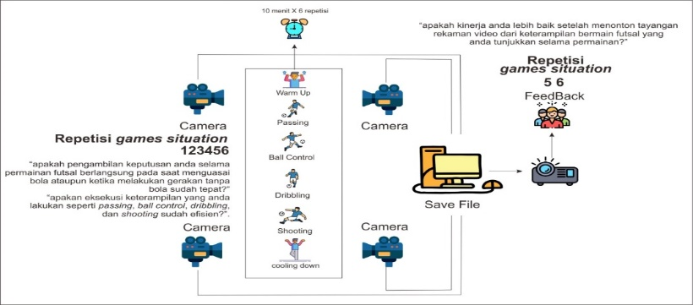

Figure 2. Implementation of Video Feedback Technology in Futsal

# **Results of Analysis and Discussion**

During the socialization activities, the community service team focused on analyzing the current state of futsal achievements in Kuningan Regency, highlighting challenges such as stagnant athlete performance and manual administrative processes. These discussions aimed to identify obstacles and introduce technology-based solutions to enhance player achievements and organizational efficiency (Potdevin et al., 2018; Pot et al., 2014).

# **3.1. Socialization Stage**

In the opening session, the community service team presented the results of the analysis of the futsal team's performance in various local and regional tournaments. Data indicated that Kuningan Regency's achievements remain stagnant, with a relatively low win rate compared to neighboring regions.

This is influenced by several factors, including limited adequate training facilities, lack of use of modern technology in skill development, and conventional training patterns. One problem that is of particular concern is the minimal use of structured performance analysis methods, such as video feedback, which has been proven effective in improving the technical and tactical skills of players (Prilop et al., 2020; Koekoek et al., 2018; Palao et al., 2015).

This socialization ended with an interactive discussion between the community service team and the management of the Kuningan Regency Futsal Association. The management conveyed their aspirations regarding the need for improved training facilities and athlete development, and fully supported efforts to modernize administration to be more efficient and professional. A joint commitment to make changes for the better was taken, with the hope of encouraging increased futsal achievements in Kuningan Regency in the future. Here we present a picture of the implementation of the Community Service team's socialization to AFKab Kuningan partners.

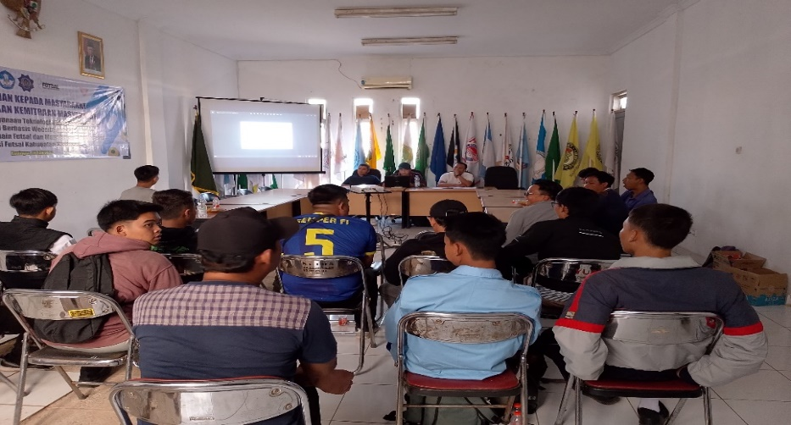

Figure 3. Socialization of the Implementation of Community Service Activities

In the socialization activity, the Community Service team also conveyed the purpose of this activity. The purpose of this Community Service is to provide real contributions to the development of futsal sports in Kuningan Regency through a modern technology and management approach. This socialization focuses on two main objectives that are expected to bring significant changes to improving the quality of futsal games in Kuningan Regency (Pyle, B., & Esslinger, 2014; Prilop et al., 2020).

Through this socialization, the community service team introduced how to use Video Feedback as an effective tool in improving the performance of futsal players. The implementation of this technology is expected to not only improve individual player playing techniques, but also improve team tactical understanding. The downstreaming of the results of this research aims to ensure that Video Feedback technology can be widely applied in futsal clubs in Kuningan Regency, thus having a positive impact on the achievement of athletes in various competitions (Seidel et al., 2011; Weber et al., 2018).

# **3.2. Training Stage**

The training activities carried out by the Community Service implementation team aim to support the improvement of training quality, especially futsal playing skills. This activity was attended by all club coaches under the auspices of AFKab Kuningan. In the first session, the Community Service implementation team provided training on understanding the use of video feedback technology in the futsal training process. This session was designed to train coaches to be able to utilize video technology as a tool to analyze player performance more effectively. In this training, coaches were introduced to basic video recording techniques that are relevant to training, such as the right angle and ideal distance to record player movements. The Community Service Team also explained how to utilize video analysis software to break down player movements into detailed parts so that coaches can provide more specific feedback on game techniques, strategies, and tactics (Anggit Wicaksono, 2018).

Through simulations and hands-on practice, coaches had the opportunity to test how video feedback works and learn how to direct players’ attention to areas that need improvement. The results of the training showed high enthusiasm from the coaches. Many found the use of this technology helpful in identifying and correcting player errors, and recognized the great benefits of video feedback in improving players’ understanding of their roles on the field (Ketchum et al, 2022; Middlemas & Harwood, 2018).

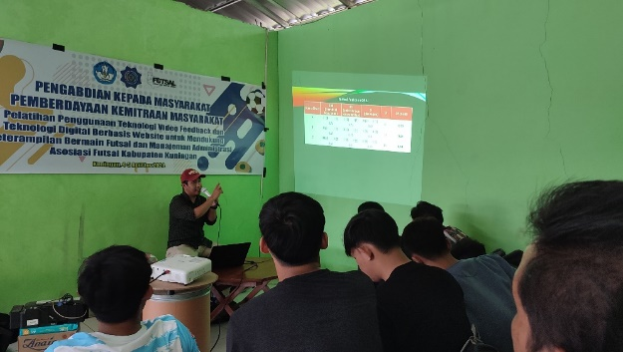

Figure 4. Training on the Use of Video Feedback for Trainers

The training on the application of video feedback technology to all futsal club coaches was held for two days, precisely on August 5 and 6, 2024, from 14.00 - 17.00 WIB. The equipment/tools used in the training activities consisted of video recordings of players' futsal training as joint evaluation materials, a laptop to store video recording files, an HDMI cable to forward video recordings from the laptop to the infocus, and an infocus to display video recordings to the coaches. The evaluation process in the training activities for coaches was given a questionnaire about their perceptions of the need to implement this video feedback technology as one way to improve futsal playing skills.

# **3.3. Technology Implementation Stage**

The implementation stage of video feedback technology by the Community Service implementation team is a continuation of the training program aimed at improving the quality of training and futsal playing skills in clubs under the auspices of the Kuningan Regency Futsal Association (AFKab). After the coaches received training in using this technology, the Community Service team facilitated the direct implementation of video feedback during training sessions, involving players from all futsal clubs in AFKab Kuningan. In implementing this video feedback technology, the Community Service implementation team helped coaches record player training at important moments, such as basic ball control techniques, shooting accuracy, game patterns, and coordination between players. The recorded videos were then analyzed together with the coaches and players, allowing them to review the movements and decisions made while playing. Through this visual analysis, players can more easily understand each other's strengths and weaknesses, and recognize mistakes that need to be fixed specifically (Fauzi, 2015).

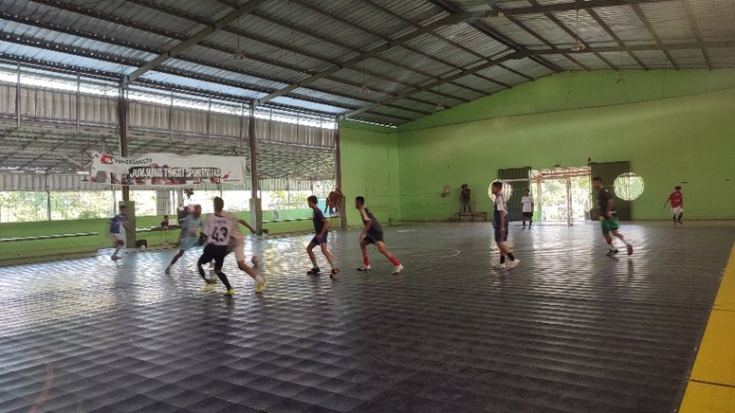

Figure 5. Application of Video Feedback Technology in Futsal Training

The results of the application of video feedback technology show that players can get more detailed and effective feedback. By using video, coaches provide more targeted guidance on aspects that need to be improved, such as body posture, shooting angles, and movement patterns. In addition, video feedback also helps players understand optimal positions and more effective tactics in coordinating with teammates (Aiken et al., 2012; Fairbrother et al., 2012).

In the evaluation session, many coaches and players felt the real benefits of implementing this technology. Players admitted that it was easier to understand the instructions given, because they could see the situation on the field directly. They felt more motivated to improve their performance because they had a clear picture of the aspects that needed to be improved. For coaches, this technology is an important tool in providing more accurate and data-based instructions, so that the training process becomes more effective and structured (Guadagnoli et al., 2002; Meade et al., 2014).

Overall, the application of video feedback technology in futsal training not only helps improve the quality of individual players, but also strengthens team coordination and understanding of tactics. With continued implementation, it is hoped that this technology can become an integral part of coaching futsal players in Kuningan Regency, so that it can produce athletes who excel and compete at a higher level.

Referring to the purpose of community service activities that the implementation of the application of video feedback technology is to improve the futsal playing skills of club players under the auspices of AFKab Kuningan. So that the focus in the technology application stage is that players get feedback from the video results of the training process displayed on playing skills which include (decision making, execution skills, and support). The data from the measurement results of the futsal playing skills shown by the players specifically will be explained at the mentoring and evaluation stage.

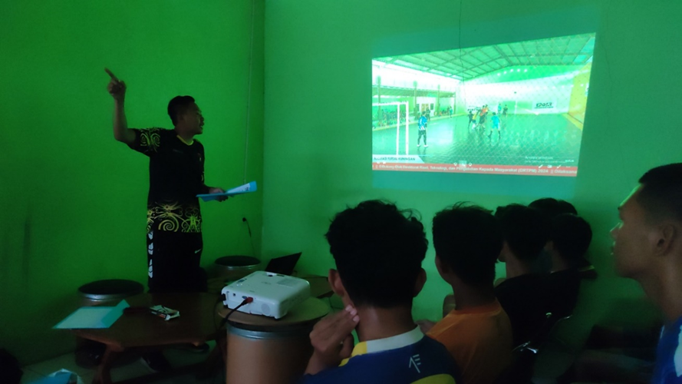

Figure 6. Providing Feedback via Futsal Training Results Video

# **3.4. Mentoring and Evaluation Stage**

In the mentoring and evaluation stage, the Community Service implementation team carried out intensive activities with partners to support the success of the community service program. This mentoring focused on the use of video feedback in an effort to improve futsal playing skills, which was supported by data collection through observation using the Games Performance Assessment Instrument (GPAI). The team and partners prepared a training schedule and provided technological devices to record and analyze each athlete's game. Through regular observation and feedback sessions, the team and partners were able to identify the technical and tactical abilities of players that needed to be improved. In the program evaluation, the implementation team and partners held a joint reflection session to assess the impact of implementing the use of video feedback on the performance of futsal athletes. Data hasil observasi selanjutnya dihitung menggunakan rumus Mitchell, Oslin, dan Griffin (Griffin, L, L., 2018). Adapun perhitungan keterampilan bermain menurut GPAI adalah sebagai berikut:

1. Decision Making Index (DMI): is the number of correct decisions made divided by the number of correct decisions plus the number of incorrect decisions, DMI = (A / (A + IA)).
2. Skill Execution Index (SEI): is the number of efficient skill executions divided by the number of efficient skill executions plus the number of inefficient skill executions, SEI = (E / (E + IE)).
3. Support Index (SI): is the number of correct support decisions made divided by the number of correct decisions plus the number of incorrect decisions, SI = (A / (A + IA)).
4. Game Engagement (GI): Add together all responses indicating game engagement. GI = DMI + SEI + SI.
5. Sports Game Playing Ability (GP): Sports game playing ability is calculated by adding the scores of all assessed components and dividing by the number of assessed components, GP = (DMI + SEI + SI) / 3

Based on the results of observations using the GPAI instrument, there was a significant increase in futsal players after the application of video feedback technology in aspects of playing skills, such as decision-making skills, execution skills, and awareness of player positions on the field (support). The results of the futsal playing skills of the AFKab Kuningan club players can be seen in the pretest and posttest results presented in table 1 below:

**Table 1.** Pretest and Posttest of Futsal Players' Playing Skills Using the Games Performance Assessment Instrument (GPAI)

|  |  |  |  |
| --- | --- | --- | --- |
| **No** | **Club Name** | **Futsal Playing Skills** | |
| **Pretest** | **Posttest** |
| 1 | A.N FC Ciawi Gebang | 0,64 | 0,75 |
| 2 | JNE Futsal Kuningan | 0,73 | 0,87 |
| 3 | SWR Vik | 0,65 | 0,76 |
| 4 | SPM Klub Futsal | 0,63 | 0,73 |
| 5 | Toko Kecil | 0,71 | 0,79 |
| 6 | Rahayu Putra | 0,72 | 0,85 |
| 7 | Nass Kuningan | 0,68 | 0,81 |
| 8 | Mumeda Kalismaya | 0,67 | 0,78 |
| 9 | Budi Bahkti | 0,66 | 0,75 |
| 10 | Bayuning FC | 0,68 | 0,77 |
| 11 | Akatsuki | 0,65 | 0,76 |
| 12 | Damar Sakti Futsal | 0,66 | 0,78 |
| 13 | Zidni Futsal Klub | 0,67 | 0,77 |
| Total | | 8,75 | 10,17 |
| Average | | 0,67 | 0,78 |

The following is a statistical description of the futsal player data consisting of 182 people, who are members of 13 futsal clubs in the Kuningan Regency Futsal Association. Based on statistical data from the results of community service activities regarding the implementation of video feedback technology in supporting futsal playing skills, there was an increase in the results in the posttest compared to the pretest. At the pretest stage, the total number of points obtained was 8.75 with an average value of 0.67. After the intervention using video feedback technology, the posttest data showed an increase, with the total value reaching 10.17 and an average value of 0.78. This shows an increase of 1.42 in the total number of points and an average increase of 0.11. The implementation of video feedback technology seems to play a positive role in improving futsal playing skills, as reflected in the increase in posttest scores.

# **3.5. Program Sustainability Stage**

At the sustainability stage of the program, the Community Service implementation team and partners follow up to make partners a research laboratory for students. With this development, partners not only act as beneficiaries, but also as a place for student field practice and research that is relevant to the field of sports, especially futsal. This agreement opens up opportunities for students to apply scientific concepts through sustainable and research-based activities. The Community Service implementation team also prepares an assignment scheme for students to carry out scientific development collaboration in the form of Independent Learning Independent Campus (MBKM) activities, especially through independent projects and internships. Students are given the opportunity to be directly involved in futsal team management activities and developing training strategies, including using video feedback and website-based digital technology that has been implemented. Through this involvement, students are expected to be able to develop practical skills and in-depth understanding in the fields of coaching and sports management. This sustainability activity not only supports student learning, but also contributes to partners in improving the quality of futsal training and management. With ongoing collaboration, partners act as dynamic laboratories for students, supporting the development of knowledge and practical skills in supporting learning outside the classroom according to the MBKM principles (Krishnapatria, 2021; Vhalery et al., 2022; Simatupang & Yuhertiana, 2021).

# **Conclusion**

Community service activities have succeeded in improving the futsal playing skills of futsal club players in the Kuningan Regency Futsal Association. The use of Video Feedback (VFB) technology has proven effective in helping players and coaches conduct direct evaluations of the game, thus facilitating improvements in technique, tactics, and overall team coordination. Through VFB, coaches can provide more specific feedback, while players can better understand their weaknesses and potential.

# **Acknowledgments**

With great gratitude, we would like to express our deepest gratitude to the Directorate of Research, Technology, and Community Service (DRTPM) for the support of the 2024 community service grant funds that have been provided, so that the community service activities entitled "Implementation of Video Feedback Technology to Support Futsal Playing Skills" can run well and achieve the expected results. Support from DRTPM has enabled us to utilize modern technology in futsal training, which is very beneficial for improving the skills and understanding of players and coaches. This assistance is not only a driver for the creation of innovation in futsal training methods, but also a motivation for us to continue to make positive contributions to society. We hope that this good cooperation can continue and have a broad impact on improving the quality of sports at the local and national levels. Once again, we express our sincere gratitude to DRTPM for the trust and support given.

**References**

Aiken, C. A., Fairbrother, J. T., & Post, P. G. (2012). The effects of self-controlled video feedback on the learning of the basketball set shot. *Frontiers in Psychology*, *3*(SEP), 1–8. https://doi.org/10.3389/fpsyg.2012.00338

Alex Adams, Don Belcher, Alysia Jenkins, & T. G. (2024). Utilizing Video Feedback for Effective Motor Skill Learning in Online Physical Education. *International Journal of Kinesiology in Higher Education*. https://doi.org/https://doi.org/10.1080/24711616.2024.2421764

Anggit Wicaksono. (2018). Videotapes Feedback untuk Meningkatkan Prestasi Atlet Nomor Lempar Atletik. *Journal of Sport Coaching and Physical Education*, *3*(14–19).

Cheri Ketchum, Elaine Phompheng, Chelsey Yeats, Daria LaFave, & J. H. (2022). The Impact of Video Feedback on Student Assessments and Performance. *American Journal of Distance Education*, *36*(4), 288–301. https://doi.org/https://doi.org/10.1080/08923647.2022.2073113

Fairbrother, J. T., Laughlin, D. D., & Nguyen, T. V. (2012). Self-controlled feedback facilitates motor learning in both high and low activity individuals. *Frontiers in Psychology*, *3*(AUG), 1–8. https://doi.org/10.3389/fpsyg.2012.00323

Fauzi, F. F. (2015). *Pengaruh Penggunaan Video Tape Feedback Terhadap Keterampilan Teknik Dasar Dribbling Cabang Olahraga Futsal*. Universitas Pendidikan Indonesia.

Griffin, L, L., O. & M. (2018). The game performance assessment instrument (gpai): development and preliminary validation. *Journal of Teaching in Physical Education*, *17*, 231–243.

Guadagnoli, M., Holcomb, W., & Davis, M. (2002). The efficacy of video feedback for learning the golf swing. *Journal of Sports Sciences*, *20*(8), 615–622. https://doi.org/10.1080/026404102320183176

Hadiana, O., Wahidi, R., & Agustan, B. (2020). Efektivitas penerapan video feedback (VFB) terhadap motivasi belajar pada pembelajaran futsal. *SPORTIF: Jurnal Penelitian Pembelajaran*, *6*(1), 184–198.

Hadiana, O., Wahidi, R., Sartono, S., & Agustan, B. (2020). *The Impact of Video Feedback Toward Futsal Playing Skills*. *21*(Icsshpe 2019), 68–70. https://doi.org/10.2991/ahsr.k.200214.019

Koekoek, J., van der Mars, H., van der Kamp, J., Walinga, W., & van Hilvoorde, I. (2018). Aligning Digital Video Technology with Game Pedagogy in Physical Education. *Journal of Physical Education, Recreation and Dance*, *89*(1), 12–22. https://doi.org/10.1080/07303084.2017.1390504

Krishnapatria, K. (2021). Merdeka Belajar-Kampus Merdeka (MBKM) curriculum in English studies program: Challenges and opportunities. *ELT in Focus*, *4*(1), 12–19. https://doi.org/10.35706/eltinfc.v4i1.5276

Meade, E. B., Dozier, M., & Bernard, K. (2014). Using video feedback as a tool in training parent coaches: promising results from a single-subject design. *Attachment and Human Development*, *16*(4), 356–370. https://doi.org/10.1080/14616734.2014.912488

Meer, Bart R. van der, Michel A. C. van den Hoven, John van der Kamp, & G. J. P. S. (2023). Self-Controlled Video Feedback Facilitates the Learning of Tactical Skills in Tennis. *Research Quarterly for Exercise and Sport*, *95*(2), 537–545. https://doi.org/https://doi.org/10.1080/02701367.2023.2275801

Mehmet Fatih Yiğit. (2021). Effect of video feedback on students’ feedback use in the online learning environment. *Innovations in Education and Teaching International*, *60*(1), 15–25. https://doi.org/https://doi.org/10.1080/14703297.2021.1966489

Middlemas, S., & Harwood, C. (2018). No Place to Hide: Football Players’ and Coaches’ Perceptions of the Psychological Factors Influencing Video Feedback. *Journal of Applied Sport Psychology*, *30*(1), 23–44. https://doi.org/10.1080/10413200.2017.1302020

Palao, J. M., Hastie, P. A., Cruz, P. G., & Ortega, E. (2015). The impact of video technology on student performance in physical education. *Technology, Pedagogy and Education*, *24*(1), 51–63. https://doi.org/10.1080/1475939X.2013.813404

Pot, N., Schenk, N., & van Hilvoorde, I. (2014). School sports and identity formation: Socialisation or selection? *European Journal of Sport Science*, *14*(5), 484–491. https://doi.org/10.1080/17461391.2013.873483

Potdevin, F., Vors, O., Huchez, A., Lamour, M., Davids, K., & Schnitzler, C. (2018). How can video feedback be used in physical education to support novice learning in gymnastics? Effects on motor learning, self-assessment and motivation. *Physical Education and Sport Pedagogy*, *23*(6), 559–574. https://doi.org/10.1080/17408989.2018.1485138

Prilop, C. N., Weber, K. E., & Kleinknecht, M. (2020). Effects of digital video-based feedback environments on pre-service teachers’ feedback competence. *Computers in Human Behavior*, *102*(August 2019), 120–131. https://doi.org/10.1016/j.chb.2019.08.011

Pyle, B., & Esslinger, K. (2014). Utilizing technology in physical education: Addressing the obstacles of integration. *Delta Kappa Gamma Bulletin*, *80*, 35–39.

Roure, C., Méard, J., Lentillon-Kaestner, V., Flamme, X., Devillers, Y., & Dupont, J. P. (2019). The effects of video feedback on students’ situational interest in gymnastics. *Technology, Pedagogy and Education*, *28*(5), 563–574. https://doi.org/10.1080/1475939X.2019.1682652

Seidel, T., Stürmer, K., Blomberg, G., Kobarg, M., & Schwindt, K. (2011). Teacher learning from analysis of videotaped classroom situations: Does it make a difference whether teachers observe their own teaching or that of others? *Teaching and Teacher Education*, *27*(2), 259–267. https://doi.org/10.1016/j.tate.2010.08.009

Simatupang, E., & Yuhertiana, I. (2021). Merdeka Belajar Kampus Merdeka terhadap Perubahan Paradigma Pembelajaran pada Pendidikan Tinggi: Sebuah Tinjauan Literatur. *Jurnal Bisnis, Manajemen, Dan Ekonomi*, *2*(2), 30–38. https://doi.org/10.47747/jbme.v2i2.230

Vhalery, R., Setyastanto, A. M., & Leksono, A. W. (2022). Kurikulum Merdeka Belajar Kampus Merdeka: Sebuah Kajian Literatur. *Research and Development Journal of Education*, *8*(1), 185. https://doi.org/10.30998/rdje.v8i1.11718

Wahidi, R., Firmana, I., Hadiana, O., Kusmaedi, N., Ma’mun, A., Mulyana, B., & Syamsudar, B. (2021). Meningkatkan Kemampuan Teknik Dasar Dribbling Melalui Penggunaan Video Feedback (VFB) Dalam Pembelajaran Futsal. *Jurnal Pendidikan Jasmani Dan Olahraga*, *6*(2), 224–228. https://doi.org/10.17509/jpjo.v6i2.33692

Weber, K. E., Gold, B., Prilop, C. N., & Kleinknecht, M. (2018). Promoting pre-service teachers’ professional vision of classroom management during practical school training: Effects of a structured online- and video-based self-reflection and feedback intervention. *Teaching and Teacher Education*, *76*, 39–49. https://doi.org/10.1016/j.tate.2018.08.008

|  |
| --- |
| **Copyright holder :** ©The Author(s)  **First publication right** : Jurnal Pengabdian Pada Masyarakat Membangun Negeri  **This article is licensed under:** CC-BY**-SA** |